**BLOCKCHAIN SUPPLEMENTING MAGNIFICATION OF SECURITY IN SUPPLY CHAIN MANAGEMENT**

**A Project Report**

**Submitted By:**

**ANUSHKA (ROLL NO: -180101069)**

**ABHISHEK KUMAR (ROLL NO: -180102003)**

**LUCKY KATIYAR (ROLL NO: -180101194)**

In partial fulfillment for the award of the degree

of

**BACHELOR OF TECHNOLOGY**

**IN**

**COMPUTER SCIENCE & ENGINEERING**

At



**SHARDA UNIVERSITY**

**Knowledge Park III, Greater Noida, Uttar Pradesh 201310**

**CERTIFICATE**

This is to certify that the project entitled “*BLOCKCHAIN SUPPLEMENTING MAGNIFICATION OF SECURITY IN SUPPLY CHAIN MANAGEMENT*” has been presented to the Department of Engineering and Technology, (Sharda University) for the fulfillment of the requirement for the award of the degree of Bachelor of Technology in “Computer Science and Engineering” by following students of final year B. Tech (CSE). The original research work was carried out by them under my supervision in the academic year 2021-22. On the basis of the declaration made by them, I recommend the project report for evaluation.

Students Name (Roll No.)

Anushka (180101069)

Abhishek Kumar (180102003)

Lucky Katiyar (180101194)

Dr. Bharat Bhushan Sir Dr. Nitin Rakesh

(Project Guide) (Head of Department)

**DECLARATION**

We, hereby declare that the discussion entitled “Enhancement of Security In Exchanges in Supply Chain Management” being submitted by us towards the partial accomplishment of the degree of Bachelor of Technology in the Department of Computer Science and Engineering is a project work carried by us under the supervision of Dr. Bharat Bhushan, and has not been submitted anywhere else. We will be entirely responsible if any kind of plagiarism is found.

Date: 10-06-2021 Name:

Anushka (180101069)

Abhishek Kumar (180102003)

Lucky Katiyar (180101194)

**ACKNOWLEDGMENT**

We would like to share our sincere gratitude to all those who assisted us in the completion of this project. During work, we faced many challenges due to our lack of knowledge in the Blockchain domain, but we were constantly helped and pointed to shape this project in its true form. We would like to thank our guide Dr. Bharat Bhushan who kept directing us towards our next tasks to meet the requirements. It was his expertise and immense knowledge that helped us sail through smoothly.

We would also like to show our gratitude to our Project Coordinator Mrs. Kanika Singla for her constant monitoring during the project work.

Our team is thankful to Mr. Parma Anand, Mr. Nitin Rakesh, and all the Faculties and Staff of the Department of Computer Science and Engineering, Sharda University, for their help and support towards this project and our team.

ANUSHKA (180101069)

ABHISHEK KUMAR (180102003)

LUCKY KATIYAR (180101194)

**ABSTRACT**

Managing the integrity of products and processes in a supply chain environment is a significant challenge. Amongst other solutions, Blockchain has emerged as advanced technology, since it provides secure traceability and control, immutability, and trust creation among stakeholders in a low-cost IT solution. Although Blockchain is reshaping many areas, there are many impediments to its widespread adoption in supply chains. Supply chains hold complex networks of suppliers, manufacturers, distributors, retailers, auditors, and consumers. A blockchain’s shared IT infrastructure would shape workflows for all companies, no matter the volume of the enterprise network. In this research work, we analyze the current secured and transparent digitalization of the supply chain. And provide a brief survey on the enhancement of securities in supply-chain management using blockchain and the challenges encountered during the integration. Furthermore, we highlight the uses of the blockchain-based business and future research challenges linked with them. Ultimately, we'll propose a novel framework for Blockchain-enabled supply chains which produces more security to carry forward the course of the commodity in the supply chain.

**TABLE OF CONTENT**

|  |  |  |
| --- | --- | --- |
| **Sr no.** | **Content** | **Page** |
| 1. | Certificate | 1 |
| 2. | Declaration | 2 |
| 4. | Acknowledgement | 3 |
| 5. | Abstract | 4 |
| 6. | Chapter-1: Introduction to Blockchain and Supply Chain | 7 |
| 7. | Introduction | 7 |
| 8. | Literature Review | 7 |
| 8. | Blockchain Overview | 9-11 |
| 9. | Supply Chain Overview | 11-14 |
| 10. | Chapter-2: Decentralized Applications for LSCM | 15 |
| 11. | DApp for logistics and supply chain operations | 15 |
| 12. | Statement of problem | 17 |
| 13. | Aim and Objective | 17 |
| 14. | Tech stack to be used | 17 |
| 15. | Results and outputs | 18 |
| 16. | REFERENCES | 27 |

**LIST OF FIGURES**

|  |  |  |
| --- | --- | --- |
| **Sr no.** | **Description** | **Page** |
| Fig. 1 | Blocks of Blockchain network | 14 |
| Fig. 2 | Architecture of BCT enabled SCM | 25 |
| Fig. 3 | Working diagram of DApp | 30 |
| Fig. 4 | Working of DApp inside SCM | 31 |
| Fig. 5 | List of technologies and software to be used | 34 |
| Fig. 6 | Ganache Platform | 37 |
| Fig. 7 | Metamask network creation page | 40 |
| Fig. 8 | List of all networks offered by metamask in integration with blockchain | 43 |
| Fig. 9 | Application structure and code-base along with the browser interface | 45 |
| Fig. 10 | Browser interface | 46 |
| Fig. 11 | Details of the Account 1 associated with metamask | 47 |
| Fig. 12 | Account details associated with metamask | 48 |
| Fig. 13 | Application browser interface with valid entries. | 49 |
| Fig. 14 | Metamask pop-up window | 50 |
| Fig. 15 | Establishing of connection between application and metamask | 51 |
| Fig. 16 | Transfer confirmation page for 1-ETH | 52 |
| Fig. 17 | Payment processing page | 53 |
| Fig. 18 | Metamask account transaction status 1 | 54 |
| Fig. 19 | Metamask account transaction status 1 | 55 |
| Fig. 20 | Metamask account transaction status 1 | 56 |

**CHAPTER-1:** INTRODUCTION TO BLOCKCHAIN AND SUPPLY CHAIN

# **1. Introduction**

The confabulation around the blockchain technology first emerged in early 1991, when two researchers named Stuart Haber and W. Scott Stornetta came up with a solution to the problem of authenticity of the digital documents, they were concerned with the fact that the text, pictures, video, and audio documents are easily modified media hence it is not possible to certify such documents like when was it created when was it last modified or changed, certification of the data was necessary rather than the certification of the medium used for accessing the data, they proposed a solution of time-stamping the digital documents that could help in proving the authenticity of the data as well as make the digital document tamper-proof. Also, the time stamping system maintains the complete privacy of the document. This was the very first appearance of blockchain technology that got published in the journal of cryptology. It did not gain much popularity during that period as not many people considered data tampering a big problem.

This technology made a second appearance again in the year 1992, when the same two researchers Stuart Haber and W. Scott Stornetta along with a new member Dave Bayer, came up with improvisation to the previous time-stamping system proposed by them, where they included a certain cryptographic hash function that could improve the system, in the proposed solution they mentioned that the cryptographic algorithm can be used to report events concisely and also to cause that the event based on the document, that too without disclosing the content of the digital documents. It was undoubtedly a good improvisation to their previous work, which also made it a quiet and engaging topic to discuss around.

Almost after a decade and a half, the technology became the most captivating and debatable topic to discuss when one of the developers from Japan Satoshi Nakamoto invented bitcoin in the year 2009, which was based on blockchain technology. Bitcoin is a digital currency also known as cryptocurrency which can be used just like any real currency, but unlike real currency it is virtual. This currency is based upon blockchain technology, it works by spreading its operation over a very wide network of computers where it can operate without the need of any central authority. It eventually reduces the human risks involved and also eliminates the transaction as well as processing fees involved. Blockchain is a bedrock not only for bitcoin but various other cryptocurrencies.

Introduced by Santoshi Nakamoto, the hype around bitcoin and blockchain technology have been acquiring tremendous attention around Supply Chain Management. Blockchain is a shared and decentralized ledger for recording, managing, storing and transmitting data in a P2P network. It uses cryptographic algorithms forming a structure like a chain of blocks containing the data. Blockchain provides a sustainable and secure architecture for the operation of the supply chain. IBM, Walmart and many other companies are investing heavily in this field to improve supply chain processes by harnessing the power of blockchain technology in various industries. The interest of the research communities is also helping the blockchain technology gaining momentum in the last few years which is evident by a series of literature reviews. Blockchain technology is inherently distributed, decentralized, and tamperproof making it a potential solution to address the issues in traditional SCM. The main objective behind it is to ensures the tranquility of mind. Security is significantly a obstreperous topic, many tend to ignore the reality rather than confront it. As we know the world is filled up with various kind of individuals, hence it is best to link yourself to right-minded people who are erudite, experienced and sophisticated. With the right technology and expertise, we are more than capable of addressing the security concerns.

Supply Chain Management is the process of managing the flow of services and goods, from transforming raw materials into a final product reaching to customers. It comprises various steps of a product life cycle and usually requires the cooperation of several businesses and stakeholders, which makes the supply chain extraordinarily complex and vulnerable too. Now a days security is predominantly an integral part of most of the businesses. Several companies that avoid utilizing this technology, leave themself vulnerable to various lethal attacks. Supply Chain security is a wide term that encircles the efforts to mitigate the risk both intrinsic as well as extrinsic threats such as intimidation, piracy, buccaneering, break-in, theft, both real as well as cyber world. In this article we have discussed and highlighted the copious security dangers posed to supply chain as well as the relevant solutions that can mitigate and even eliminate the risk.

**2. Literature Review**

To make sure a secure system is established in blockchain Hafid et al. [9] proposed a work that gives solutions to keep the failure probability smaller than a predefined threshold for a sharding protocol in blockchain. They used three probability bounds: Chvatal, Chebyshev, and Hoeffding illustrating the effectiveness of the model they proposed. They also conducted a comparative and numerical analysis of the bounds proposed. Belotti et al. [10] presented how the application of blockchain is beyond bitcoin, surveying numerous literatures of the past few years. Indicated requirements, evolution from private to public blockchains and listing the differences between proposed and consensus mechanisms. Tsoulias et al. [11] presented a decentralized application model which stores the data in Neo4j graph database assisting protocol operations and enhancing security. They implemented a consensus mechanism similar to Casper and tested its effectiveness. They used Proof-of-Work (POW) and Proof-of-State (POS) protocols to examine how incentive and consensus criteria differ for participants. Further they also conducted a series of experiments which tested the efficiency of the implemented solutions and methodologies to prevent the most common 51% attack, which is an attack from dynamic validator sets and catastrophic crashes as well.

To ensure the seamless flow of operations in the supply chain Asyrofi et al. [12] proposed a system that is based on cloud that manages supply chains using selective marketing and blockchain. They also improvised Jugo architecture to develop Selective Market (SELAT) as a connector between cloud providers and the users. It also improves the data security by tracking the changes in the supply chain by using blockchain. Rouhani et al. [13] presented a structured review focusing on smart contracts and how it has widened the horizons of blockchain’s application beyond bitcoin and other cryptocurrencies. They laid down their research study in three major categories: decentralized applications which are based on smart contracts, security tools and methods and approaches to enhance the performance of the smart contracts.

Hader et al. [14] presented an introduction of blockchain in supply chain management in the retail sector. They also offered a comprehensive study on how companies can improve their performance and build trust with their customers using blockchain technology. Reyes et al. [15] presented a work discussing the impact of blockchain, Internet of things (IoT) in the operation of SCM. They identified the benefits and implications of leveraging these technologies in a multi organizational supply chain setting. They also discussed how technology can accelerate businesses making the process transparent and cost-efficient. Hassija et al. [16] proposed at work discussing application of blockchain and other technologies to achieve secure trade. They have also discussed the solutions to vulnerabilities in the existing architecture of the supply chain. Fu et at. [17] described an intelligent operating mechanism and system structure to be applied in large production enterprise supply chains. They also constructed a data success and storage mechanism further providing a model structure for developing a blockchain based supply chain. Musigmann et al. [18] presented a work that fills the gap by implementing a bibliometric and co-citation analysis in blockchain technology and LSCM. They classified the past literature into five different categories: testing and conceptualizing blockchain applications for the operation of LSCM and the role of blockchain in digitization of supply chains. Wu et al. [19] presented a work that focuses on deployment of blockchain in future networks and vertical industries. They discussed how blockchain is being implemented in several sectors such as supply chain, finance, energy due to its ability to create a transparent and tamperproof nature. They also discussed the potential of blockchain as a solution to achieve security in laying networks. Tran et al. [20] presented a detailed study of blockchain outlining the challenges related to privacy and security further classifying the areas of application to enhance security. They enlisted several areas of application such as data management, e-voting systems, smart agriculture, cryptocurrency etc. They also proposed a framework called Privacy Preserving Blockchain Systems (PPSAF) designed specifically to resolve the issues in the agriculture industry. Finally, outlining the scope of future research. Table 1 presents a systematic overview of the related literature.

**3. Blockchain Overview**

Blockchain was based on the work of Stuart Haber, W. Scott Stornetta, and Dave Bayer in the year 1991-1992, this technology was popularized by a person Santoshi Nakamoto in 2008. This technology has gained much attention over the last decade, this technology is being used in various organizations across the globe due to its certain features such as decentralized security, transparency, immutability, and various other features which give this technology an advantage. An organization or a business engages in various kinds of transaction that to on a high scale each and every day, to carry out each transaction we need verification, to verify with your customer, client and other business partners you have certain credentials that is cross-verified by the organization by some kind of process, this process is labor-intensive and costly and hence increases the overall delivery time of a business, this is where distributed ledger comes into the picture, once you have your attributes recorded on this ledger you just have to verify it, and this verification is cost less and requires less no of individuals to carry out the whole verification process. Bitcoin using this technology has the feature to cheaply verify the funds which are engaged in transaction that are being, this technology is used to serve as a public distributed ledger for various cryptocurrencies.

Blockchain is a specific type of database rather than the traditional relational database we have. It stores the data in the blocks that is encrypted by a digital signature called hash which makes it more reliable and secure, preventing the data from tampering in a network. The first block is called the genesis block. Each of these blocks consists of the hash value of the previous block i.e., block 1 and hash of its own, the transaction data, and the nonce value. The hash value is an alphanumeric unique digital signature that is used to identify the block. These hashes are generated by using SHA-256 algorithms. Number only used once, also abbreviated as a nonce, is the number that the miner mining blocks need to dig to resolve the blockchain through various mathematical encryptions and calculations. The data that the block consists of is immutable and irreversible. Blockchain consists of multiple nodes which are managed by a peer-to-peer network. Fig. 1 depicts the blocks of a blockchain network.

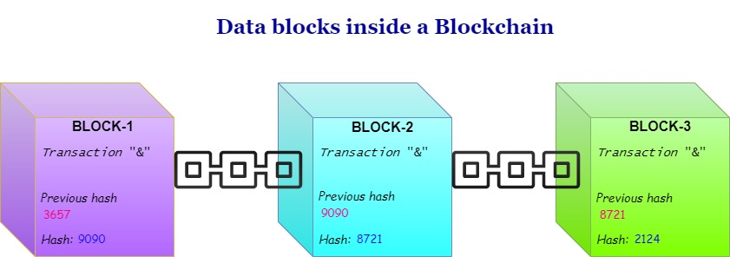

**Fig. 1 Blocks of Blockchain network**

These nodes strictly adhere to the protocol to communicate and validate the new blocks which are added to the blockchain.

**3.1. Traditional database V/S Blockchain**

**Authority:** Authority plays a significant role in blockchain technology, many of the organizations and businesses in the world are centralized which means they are controlled by an administrative body or a person with a level of high authority. Traditional databases are controlled by an administrator and are centralized in nature. While blockchain, on the other hand, is decentralized in nature and has no central authority. But private blockchain provides some centralization. It is open-source and anyone can access the codebase as well.

**Architecture:** The architecture of an organization or business decides the work flow and the process flow of the organization more the levels more is the time take to execute the process or complete the task, several traditional databases use client-server-based architecture, while blockchain, on the other hand, uses distributed ledger networks. Distributed ledgers can be maintained from any network and multiple participants to carry out the processes. Another benefit is that fraudulent activities can’t take place as well.

**Data handling:** An organization usually works on a traditional database system commonly known as CRUD (Create, Read, Update, Delete) operations while blockchain utilizes Read and Write operations as the data remains immutable in the blockchain hence it saves more time and executes the possibility of error to be caused.

**Integrity:**  Nowadays the databases used by companies and organizations are prone to malicious activities and anyone can easily hack it and tamper with the data, while blockchain supports data integrity and confidentiality with the help of distributed ledger technology as the data is always encrypted.

**Transparency:** Transparency is a key feature that keeps the process stable and running seamlessly inside an organization whereas the traditional databases used by them are not transparent and not much secure, while blockchain offers transparency. The data is stored in the blocks having a unique hash, hence making the data tamper-resistant.

**3.2. Types of Blockchain Networks**

There are 2 primary types of blockchain- Public and Private, but there are two others variations too- Consortium or Federated and Hybrid.

1. **Public:** It is a permissionless or non-restrictive distributed ledger system and anyone on the internet can access it and become part of the network, do the mining, view the records, verify the transactions, and do the proof of work for the new blocks.
2. **Private**: It is permission or restrictive ledger operative only in a closed network. It can be used within the organization or enterprises where only a few members can be part of the network, view the record, and do the mining. E.g.- Multichain.
3. **Consortium:** Unlike the public blockchain, the Consortium is controlled by multiple organizations or enterprises. E.g.- Hyperledger, Corda, Quorum.
4. **Hybrid:** It is the amalgamation of both private and public. It gives us freedom like that in public and permission access like that in private. E.g.- Ripple, and XRP.

**3.3 Cryptographic Algorithms in Blockchain**

1. **RSA (Rivest-Shamir-Adleman)** - It is an asymmetric cryptographic algorithm, which means it uses key pairs that are mathematically linked to encrypt and decrypt data.
2. **Triple DES** - Triple data encryption Algorithm is a cryptographic algorithm where block cypher algorithms are applied three times to each data block.
3. **Ethash** - It is the algorithm used to perform mining operations in Ethereum.
4. **Blowfish** - Unlike the RSA algorithm, this is a symmetric encryption algorithm that uses the exact same private key for encryption as well as decryption of messages.

**3.4 Types of consensus algorithms**

* **Proof of Work**: It is used to confirm a transaction and create new blocks in the blockchain. Also known as POW. Ethereum and Bitcoin both have proof-of-work as processor for users' transactions.
* **Proof of Stake**: It is an alternative to POW, although the use remains same for both. It consumes less energy as compared to POW. Also known as POS. Ethereum has both proof-of-stake along with proof-of-work running in the parallel.
* **Delegated Proof of Stake**: For validation on behalf of all nodes in the network, it depends upon a group of delegates. Stakeholders are elected by workers using witnesses to generate blocks.
* **Proof of Capacity**: To meet specific goals each party must have a dedicated amount of storage space, it is ensured by the algorithm.
* **Proof of Elapsed Time**: This algorithm determines mining winners and mining rights. It is used only on permissioned blockchain networks.
* **Proof of Identity**: It is the cryptographic evidence attached to a specific transaction. Also abbreviated as PoID. It is usually used in casting votes. It is used to uniquely identify each vote as single unit.
* **Proof of Authority**: It is the modified version of POS. It is used for providing comparatively faster transactions.
* **Proof of Activity**: It is a hybrid of POW and POS.

**4. Supply Chain Overview**

Supply Chain Management (SCM), is the process of managing the flow of services and goods, including every process which transforms raw materials into a final product and makes it available to the customers. Traditionally, SCM seeks to satisfy consumer's demands for a service or product with the slightest amount of inventory required for the retailer and producer. Many supply chain models were proposed and designed during the 80s when the term SCM was introduced, striving to satisfy the needs of numerous manufacturing networks. Some of the requirements include the minimization of costs from inventories and transactions, elimination of bottlenecks along the supply chain due to delays in supply delivery and payments, the creation of chains resilient to fluctuations due to the shortage of primary material and poor economic condition, the traceability of a commodities origins in a trustful and secure way, employing of local labors and producers, minimizing the transportation needs and distribution of high-grade quality products for the end consumer.

The supply chain mainly involves the production, shipment, and distribution of a product. By managing the whole process companies can cut costs and work on delivering the product faster to their customers. This is usually done by maintaining an inventory, production, sales, distribution, and inventories of vendors. The supply chain is divided into five parts based on the processes that are involved:

* Planning: The process of accurately strategizing each step of the product from raw material to the final consumer.
* Sourcing (of raw materials): The process of selecting the raw material that is required to make the product and talking to the suppliers.
* Manufacturing: The processes of creating the product from raw material to finished goods which can be shipped.
* Logistics and delivery: The process of setting up the delivery process and sending out the product to its destination.
* Return system (in case of defects in the products): If there are defects in the product, the company replaces the product with the same kind of another item.

# 

**4.1 Importance of security in Supply Chain**

Poor management of supply chain and lack of security are the major concerns related to supply chain as it can lead to losses and harm to business running around the world. If not implemented wisely, there will be delays in services reaching to customers, wasted labor, and significant increase cost of providing services while maintaining data privacy. The aim should be establishing a supply chain that reduces cost, risk, and helps the business to stay ahead in a competitive market while making sure that customer’s data is safe, there are no third-party risk or malicious activities, or cyber-attacks taking place in the supply chain.

Using blockchain technology in integration with the supply chain is assumed to be the end of all solution that requires transparency and visibility. Blockchain technology has the potential to fix the problem of complexity that lies within today's supply chain network. There have been many events in the supply chain where we saw the products were prone to fraud, malicious activity or not being able to trace them, making the deliveries late or no delivery at all. Resilinc is providing the solution to the supply chain in terms of mapping, monitoring, and resiliency solution, it is one of the worlds leading solutions providers. Resilinc provided data in 2020, which says more than 6,192 alerts were sent out related to the potential supply chain disruptions to their customers including today’s biggest multinational organizations which is a 67% increase since 2019. Some of the supply chain concerns are as follows:

1. **Data protection:** Data is the core component of any business; hence it becomes of utmost importance to secure from tampering, companies use their data to carry out various kinds of transactions on a large scale.
2. **Third-party risk**: To meet the quality demand of the customer many organizations these days are dependent upon third party tires for catering to specific tasks in the supply chain, this dependency also give rise to various risking factors such as unrestricted access to some of the organization's data, granting access to processes without getting much involved with the third party, etc.
3. **Data locality:**  There are multiple levels inside a supply chain network along with each tier of the supply chain there exists some critical data and this data needs to be protected, categorized, and located no matter how and where it is.
4. **Fraud prevention:** Inside a supply chain network the format of data keeps on changing we can find it in paper format, digital format, or any other. Whenever this data is exchanged usually from one format to another, it gets exposed to several vulnerabilities, tampering hence leading to data integrity distributions.
5. **Data visibility and governance:** Multiple organizations and businesses exchange the data for the sake of businesses that also allow them to transfer, view, inspect and collaborate with each other. An organization in participation demands control over the data and it has the ability to decide with whom to share, and what each permission party can view.

**4.2 Blockchain in supply chain operations**

Blockchain creates an immutable, auditable, transaction history that can be found to verify the identity. It becomes more appealing because of its wide variety of applications and fundamental properties which are described below. Blockchain provides data transparency across the networks which potentially decreases the transfer of data errors which also means that less time will be spent validating the data. Blockchain helps in cost-cutting by providing a trusted system for traceability and keeping track of records hence increasing the efficiency of the complete supply chain process. It also helps in maintaining the history of transactions and records of the products sold out in chronological order. There is no interference from the third parties that are involved in the transaction as it takes place directly in the blockchain-enabled supply chain. The traditional supply chain comes with so many human errors, involvement of third parties, and data tempering which can be completely eradicated with the introduction of blockchain in the supply chain.

* Parties agree upon the occurrence of transaction.
* Parties agree on the individual identities of those who are participating in the transaction.
* Parties agree upon transaction occurrence time.
* The complexness of the transaction is easily verifiable, reviewable and it is not a subject to dispute.
* Evidence for each transaction continues, which is unaltered over time.

There are so many benefits associated with supply chain which is supported by blockchain following are few of them:

1. **Provision of one universal database:** With blockchain we can maintain a single ledger to keep records on a decentralized network.
2. **Accurate data traceability along with the assets:** With blockchain we can trace the product in real time. As the whole system is digital the process of dealing with large and complex data.
3. **Reduces cost**: As the system is all digital there is reduction in the cost of labor and many third-party involvements.
4. **Quick quality analysis process:** As she complete process is digitalized the analysis process takes less time.
5. **Ability to satisfy customer:** The complete process is cost effective and the product reaches to the customers within the time that was analyzed.
6. **Higher ROI (Return of Investment)**: Blockchain sure does help enhancing the brand value hence increasing the ROI.

The above-listed properties result in a system that, by design and timestamp records all transactions in a very secure and permanent manner, is easily auditable, and is highly resilient to downtime. With various parts moving and different levels of tires and suppliers involved, supply chain can be easily prone to disruptions. It can really help keeping the record of date, quality, location, certificate, price, and other related information to manage the supply chain. This information can help increase the traceability of the product leading to lower losses, improve transparency and participant’s visibility and enhance an organization’s position in the market and also reduce the paperwork. Therefore, the characteristics of blockchain are well suited to supply chain and security settings. Fig. 2 shows the general architecture of blockchain enabled supply chain operations and the process is explained below: -

* A request for new transaction authentication is made by the user/ client.
* Then the transaction is sent to all the computers available in the network. These computers then validate the transaction. Once validation is done the transaction is complete.
* And a block is added to the chain where there are all the other blocks linked together in a form of a chain.

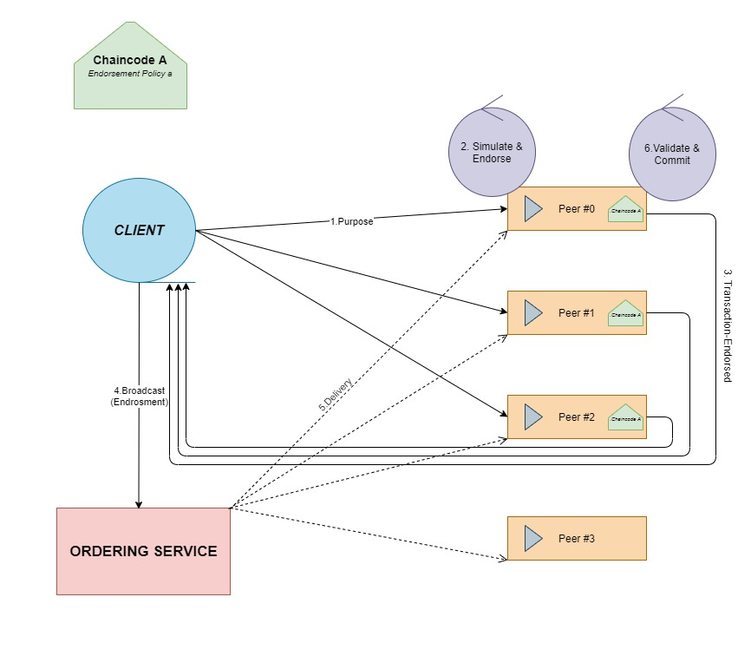

**Fig. 2 Architecture of BCT enabled SCM**

**4.3 Instances of Blockchain in Supply Chain**

1. In collaboration with IBM, Abu Dhabi National Oil Company (ADNOC)- state owned oil company, together have launched a blockchain supply chain pilot program. The aim is to track oil from customers and record transactions at every step.
2. De Beers are the largest producers of diamonds, and they are trying to end the conflicts that often serve conflicts related to sales of diamonds in Africa. Their program, Tracr successfully tracked 100 diamonds from mine trough, the cutter, polisher to jeweler. Also, Brilliant Earth, a retailer of ethically sourced diamonds is tracking the provenance of its diamonds on the Everledger blockchain.
3. Walmart, IBM, and JD.com are working towards transparent shipping of food supplies with blockchain after the progression of other big companies like Nestle, Unilever, and Tyson Foods. Blockchain is used in the food industry for the sake of maintaining traceability. Blockchain can help with food tampering, fraud or false advertising, identifying food wastage, and checking upon food spoiling.
4. Naturipe farms, LLC uses the SAP Cloud platform to keep track of blueberries from the point of harvesting to the customer's table.
5. Origintrail and TagItSmart created their blockchain solution to keep track of stop the production of illegitimate wine with the help of QR codes.
6. During the outbreak of pandemic, vaccines played a very important role in the survival of society and civilization. Vaccines played an important role in dealing with this pandemic, but if the vaccines cannot reach the person on time it is useless so this gap is filled by blockchain enabled supply chains for distributing vaccines. IBM created a distribution network of blockchain and supply chain solutions which is an open-source blockchain platform to safely track and authenticate the lot and batch number level of vaccines, handling, temperature, and other histories.
7. Blockchain is playing a very vital role in the diamond industry as well. In 2015 many companies came up with the idea to use blockchain for sourcing diamonds. A company named Everledger was founded to bring transparency to the diamond business.
8. Blockchain prevents data from getting copied, so to own the rights to a digital art NFT has become one of the most secure ways. There is a price attached to each NFT which can be paid via digital payment wallets which are based on cryptocurrency.
9. Blockchain is being used even in voting to avoid that no one votes twice and make the whole process secure in lot of other ways. Personal information of the voters is held on blockchain. It provides end-to-end verification advantages. Blockchain has great potential to decrease the costs of organizations and increase voter turnout.
10. Blockchain is also used in supplying the oil to keep the track of it from well to customers, recording transactions every step of the way. The oil and gas supply chain industry is of complex nature and involves multiple partners and stakeholders and each supplier needs to maintain inventory or ledger.

**4.4 Blockchain emerging as the best suited solution for operations of SCM**

Blockchain has gained a great momentum since past years and it’s only increasing. Companies and industries have begun their experiments with blockchain and see it as one of the secure, transparent and reliable solutions to enable supply chain in almost every sector. It helps keeping end-to-end tracking in the supply chain and helps digitizing the process from production to delivery. Development of smart contracts helps in automating executions related to shipments, arrivals and departure, and even change in ownership. It helps establish real-time auditing for compliant workflows and processes.

It helps in digitizing the inventory management, as well. Stakeholders at each level can check and verify the data at every single point from conducting payments to tracking assets and inventory. It also makes the system error less, and reduces cost and time, as well as manpower and labor cost involved in each process which eventually reduces the possibility of human error in the entire process. This digitization of SCM has other benefits such as it helps keep their customer’s data safe and tamper proof.

**CHAPTER-2**: DECENTRALIZED APPLICATIONS FOR LSCM

**5. DApps for logistics and supply chain operations**

A decentralized application (DApp) is a kind of application built on a decentralized network, it is a combination of a front-end user interface and a program called smart contracts. It is simply software that is capable of communicating with the blockchain, and that also manages the state of various other networks. The DApp interface is very similar to a website's interface or mobile application's interface, there is not much difference in it, whereas a smart contract is a piece of program that represents the core logic behind the decentralized application that lives inside of blockchain. Fig. 3 depicts the internal working of decentralized application.

The supply chain suffers a lot of issues that hinder efficiency. The point of making the supply chain decentralized is to make it agile and flexible in a way that it still caters to the customers. Due to this blockchain came into the picture because it provides a distributed digital ledger and records the financial transactions chronologically.

We can make the supply chain decentralized:

* By using numerous fulfillment centers: We can set up multiple warehouses to reduce the delivery time.
* By managing a real-time inventory: We can implement a real-time inventory and check the history of the orders.
* Access to data at all warehouses: By maintaining complete transparency the businesses become more successful.
* Sums the increased value to customers: the decentralized supply chain is less prone to human errors, loss of data, faster delivery and increased overall accuracy and efficiency.

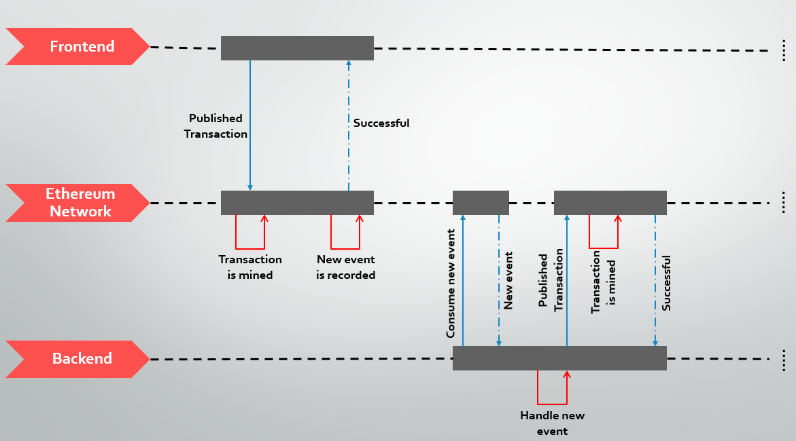

**Fig 3 Working diagram of DApps**

**5.1 How does DApps provide security in the supply chain?**

To achieve high security and reliability decentralized applications are designed on a special kind of system. A decentralized application is a secure and unalterable program that runs on a decentralized network. This application contains a front-end as well as a back-end program and together we call it a decentralized application (DApps). In this application all the major activities and not under the control of a central entity rather it is distributed among others. DApps process is surrounded by tokens. Tokens act as a fuel for the applications, in other words, they are simply currencies or assets in a virtual form. In a decentralized application, there is not a single server that stores the data. It is rather stored in the blockchain network. Hence there is no organization liable for the security of end-user data. They don't have to pay for maintenance of the server or other overheads such as staff, employees, etc. Since there is no participation of the organization in operating the network, there is less risk to sell the user's data to cover costs. It is highly secure when the data is stored in the blockchain. Fig. 4 shows how a DApp is implemented inside the supply chain system.

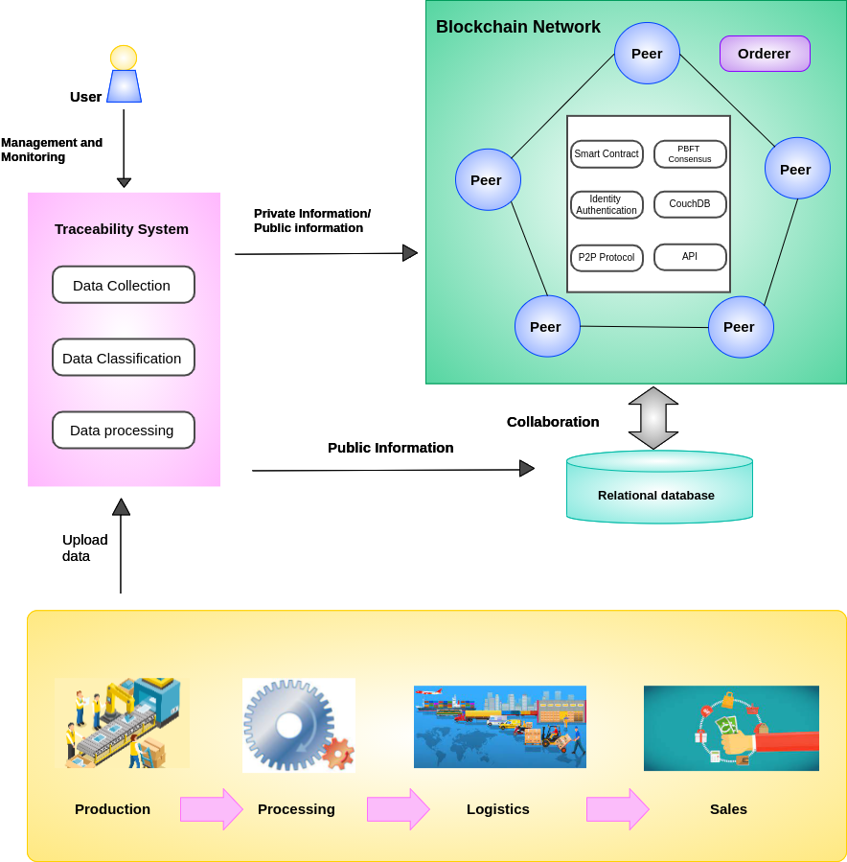

**Fig. 4 Working of DApp inside SCM**

Some of the features of DApps are listed below.

1. **Open Source:** The decentralised applications support open-source model, which means the codebase is open to all, each and every developer can collaborate on the application and it is available to the general public as well. Hence, the decentralised applications are free from any sort of central authority making it a flexible platform.
2. **Internal Currency:** The decentralised applications have their own internal currency. The creators can monetize for the assets or even real estate they own virtually in the form of decentralized MMORPG.
3. **Decentralized Consensus:** The changes in applications are determined by a consensus of its users and developers.
4. **No Central Point of Failure:** As it does not support centralised model of network, so even if the attackers try to invade into the network and perform malicious activities, they would not be able to get through the entire network of nodes that is present in the network.
5. **Highly Secure:** There is privacy for user's data, privacy from attackers because there is no single point of failure. Data is also stored into blocks which is immutable hence it has no chance of tampering or interference of any kind.

**6. Statement of the Problem**

Studying how blockchain enabled supply chain is potentially a great solution to eradicate the problems arising in the traditional supply chain while reducing the human intervention and resulting in to increased ROI. Developing and enhancing a digitally secured and transparent framework for supply chain management using blockchain technology for carrying out a valid transaction.

**7. Aim and Objective of the study**

Blockchain technology is an online ledger that uses data structure, to simplify the way we transact. It allows users to manipulate the ledger securely without the help of a third party.

Blockchain is a technology that allows the tamperproof solution to perform transactions within a decentralized network. The data cannot tamper with when stored in the block. Due to the security, transparency, and accuracy, it provides the blockchain has proved to be a great solution to enhance the traditional supply chain and digitize it. Hence, making it secure, less prone to human errors, and helping in cutting costs while increasing the traceability and accuracy of product being reached to the customer on time without any involvement of third parties. Decentralized applications run autonomously on blockchain and operate on a Peer-to-peer network, unlike traditional applications which do not provide security of data and privacy.

**8. Tech stack to be used**

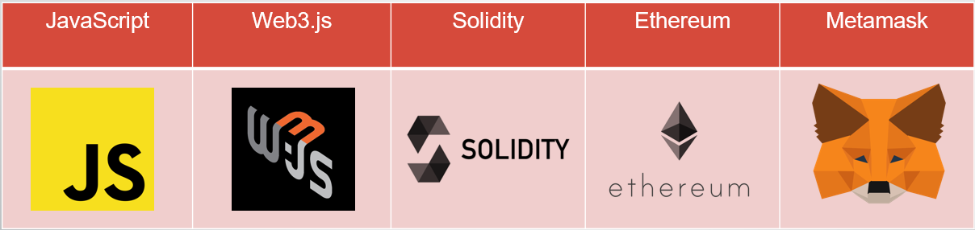

**Fig. 5 List of technologies and software to be used**

**JavaScript:** Java script is primarily used for the web; it is a scripting language that is mainly used to enhance HTML pages. Also, it is typically embedded in HTML codes. It is an interpreted language. Hence, we don't need it to be compiled, JavaScript has the capability of rendering web pages in a very dynamic and interactive manner. React processes only the user interface of the application which uses JavaScript as a language in runtime.

**Web3.js:** Web3.js is basically a collection of java script libraries which allows us to interact with Ethereum nodes locally as well as remotely. It makes our work easier by providing us with an API to interact with blockchain, that is a wrapper for JSON RPC by which we can connect to Ethereum nodes (local/remote) with IPC or HTTP connection.

**Solidity:** Solidity is mainly a high-level object-oriented language, it is designed based on some of the existing programming languages such as C++, Python, and JavaScript, hence it uses identical language formats used in these languages, which makes it easy for other developers to adopt this language. Solidity is mainly used for executing smart contracts which usually implement business logic and forge a chain of transaction records on several blockchain networks, mostly on Ethereum, it usually governs the behaviors of various Ethereum-based accounts. Solidity is a simple curly-bracket language designed to operate with Ethereum Virtual Machine (EVM). It was developed by Christian Reitwiessner, Alex Beregszaszi, and other core contributors to the Ethereum platform.

**Ethereum:** Ethereum is one of many decentralized blockchain platforms that have the capability of developing a network(peer-to-peer) that can securely verify as well as execute the smart contract, alongside it helps in maintaining the decentralized payment network bu to store computer codes which is used to power tamper-proof decentralized financial applications as well as contracts. It is best known for its native cryptocurrency also known as ETH, ether, or Ethereum. It is its distributive nature that makes this platform more secure and which enables ETH to accrue value.

**Metamask:** It is a free mobile and web crypto wallet that allows users to swap, and store cryptocurrencies and also permits interaction with the Ethereum ecosystem which is capable of hosting a growing array of decentralized applications. It is compatible with the most diverse network-Ethereum, basically, a gateway for the DeFi ecosystem, NFTs, and all others that Ethereum has to offer, another advantage of metamask is that users can explore DApps on the entire Ethereum platform without bearing the Ethereum’s full client or node. Users can access their Ethereum wallet through either metamask’s mobile application or browser extension. It is also compatible with several tokens such as ERC-20, ETH, MKR, LINK, etc.

**Ganache:** It is used for setting up a personal blockchain to test solidity contracts, it has more features to offer than any other platform such as Remix, etc. It is basically a development tool that belongs to the truffle Suite used for deploying smart contracts, running tests and deploying applications on the personal blockchain network for the quick development of Ethereum distributed applications. It provides a platform not just to develop apps but to deploy and test our DApps.

**9. Results and outputs**

* 1. **Use of each component of software in detail**

1. **Use of Ganache -** We have used ganache for creating our own private Ethereum blockchain network on our local system that will help us demonstrate our transaction related to the application, ganache here is integrated with metamask in order to carry out transactions and operations on the same local Ethereum network, we added Ganache Network with Metamask using Ganache RPC server and Network ID. Fig. 6 depicts the ganache platform used in the project

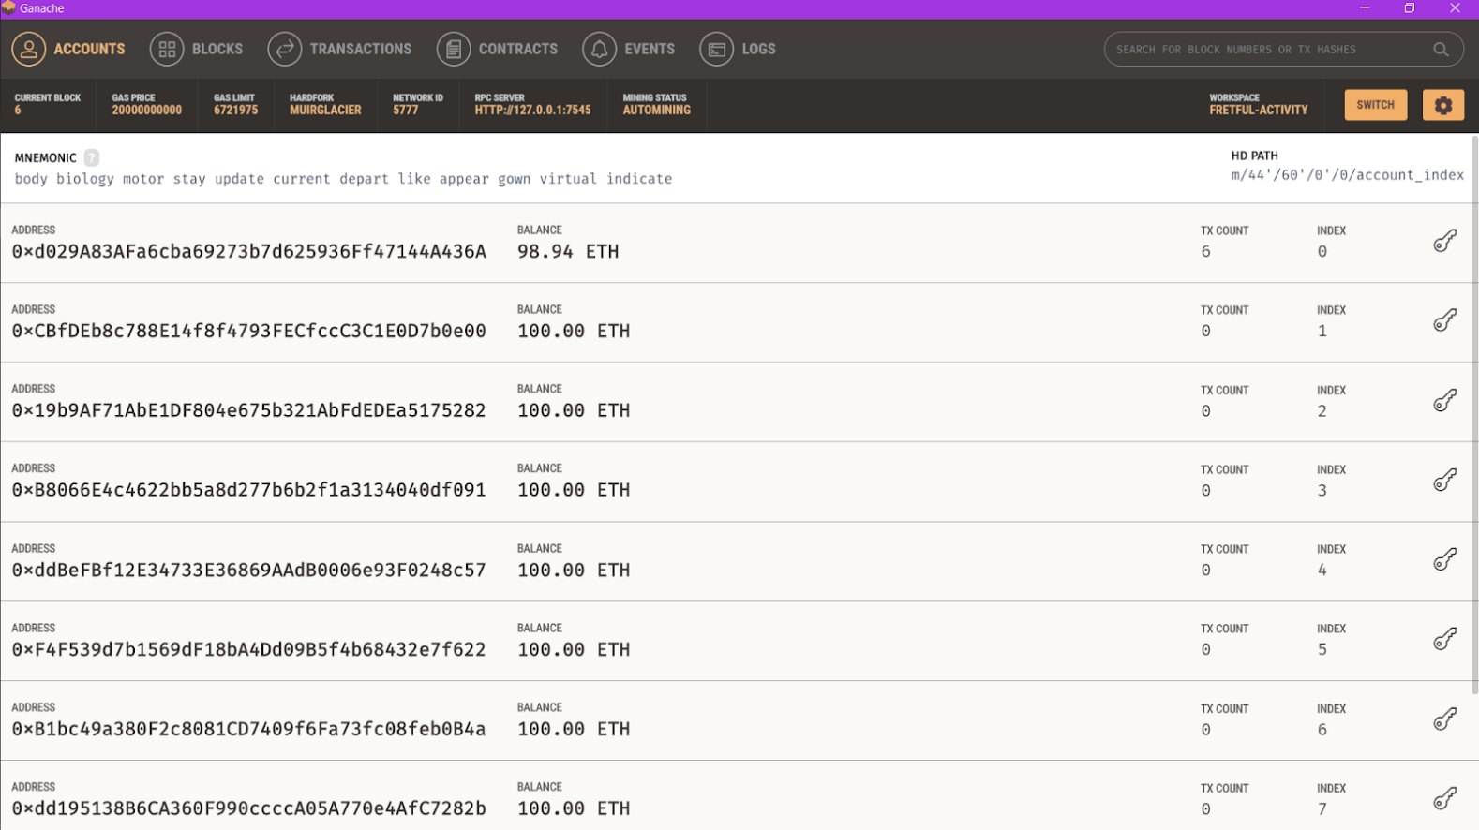

**Fig. 6 Ganache Platform**

1. **Use of Metamask –** We have used metamask for multiple purposes here such as creating a private blockchain network integrated with ganache which is providing us our Ethereum private blockchain network. Also, with the help of metamask we are carrying out a transaction on the Ethereum private blockchain network with the currency ETH, below we have explained how is the process of transaction carrying out.
   1. Creating a private network with the help of metamask integrated with ganache

**Steps**

* Go to Networks → Add Network

Inside Add Network we have multiple fields such as: -

Network Name: It is the name of the network with which Metamask will be linked.

We can either add an existing network or create our own network using ganache in our local system.

* After adding the network name, we will have to add the RPC URL.

Network URL (Remote Procedure Calls or RPC- URL): It is the URL which will be used by Metamask to access the network, RPC stands for Remote Procedure Call.

It is the URL associated with the network that we need to establish or connect to.

* Further we will add the chain id associated with that specific network.

*Chain ID*: It is the chain ID which will be used to sign the transactions for the network by Metamask.

* Further we will add a valid currency symbol for that associated with Ethereum network.

*Currency Symbol*: It is the currency symbol which will be used by Metamask for the native currency of the network.

For e.g. The currency symbol for Ethereum Main net is ETH and that for Gnosis Chain is xDAI.

Fig. 7 shows the metamask network adding page

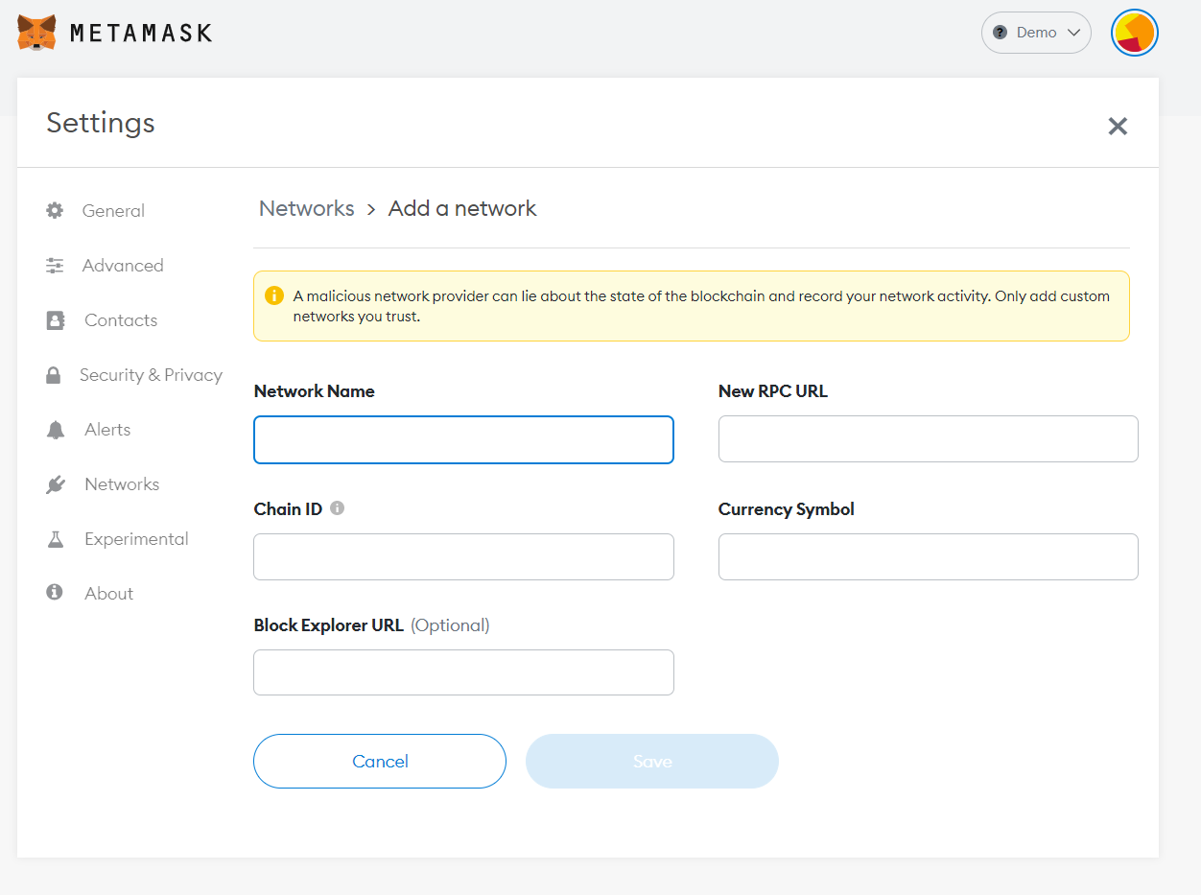

**Fig. 7 Metamask network creation page**

We can find multiple networks that can already be seen in the fig these networks are pre-created networks that are most widely used in the Ethereum network ecosystem each network has its own functionality. Also, on the right-hand side of the image, we can see the details of the network such as Network name, New RPC URL, Chain ID, Currency Symbol, Block explorer URL for which soever network selected at that time.

* Ethereum Mainnet: Mainnet is nothing but the very first public Ethereum production blockchain in use, which is capable of carrying out the actual valid valued transactions that occur on the distributed ledger. Whenever an individual or group is discussing the ETH prices scenarios, they are talking about the Ethereum Mainnet ETH.

*Test Networks* - Just like Ethereum main, there is a certain test network these networks are used by the developers who developed protocol or smart contract, it was developed to test the protocol upgrades alongside the test of the smart contract before deploying it to the Ethereum Mainnet. It is just like a staging environment before the actual production environment. It is important to test the smart contract to test it on a test network before deploying it to the Ethereum Mainnet. If we create a DApp that integrates with the already existing smart contracts, then we can find that most of the contracts have copies that are deployed to test networks and we can interact with them as well. Usually, test networks are used for the proof-of-authority consensus mechanism. This means all the small nodes are used to validate transactions for creating a new block. ETH on the test networks has no value, hence there is no market for the test networks.

* Ropsten Test Network - Ropsten Ethereum is basically a test network that is pre-configured proof-of-work, also known as Ethereum Testnet, it allows us to test the development before deploying it to the main network which is the Ethereum Mainnet. Ropsten is the successor of its previous version called Morden, which was the first Ethereum test network ever built. In addition to it, Etherium money or currency is also known as ETH or ether has no real value on this network.
* Rinkeby Test Network - Rinkeby is also one of the Ethereum test networks that has the same feature of testing the application called smart contract before deploying it to the Ethereum Mainnet. This proof-of-authority test network uses the Clique POA protocol which is a consensus protocol, it was established in April 2017, and it is maintained by the team of Geth developers.
* Goerli Test Network - Goerli is also one of the Ethereum test networks that have the same feature of testing the application called smart contract before deploying it to the Ethereum Mainnet. This proof-of-authority test network uses the Clique POA protocol which is a consensus protocol, it was originally proposed by Chainsafe and Afri Schoedon and established in March 2019.
* Kovan Test Network - Kovan is one of the Ethereum test networks that have the same feature of testing the application called smart contract before deploying it to the Ethereum Mainnet. This proof-of-authority test network uses the AuRa (authority round) which is a consensus protocol, it established in March 2017.
* Local host 8545 – Here it is the local machine on which the metamask and ganache is running currently as shown below in Fig. 8.
* Demo - is the network created by us using the credentials offered by ganache we integrated it with metamask to create our own private blockchain network as it is listed below in the Fig. 8.

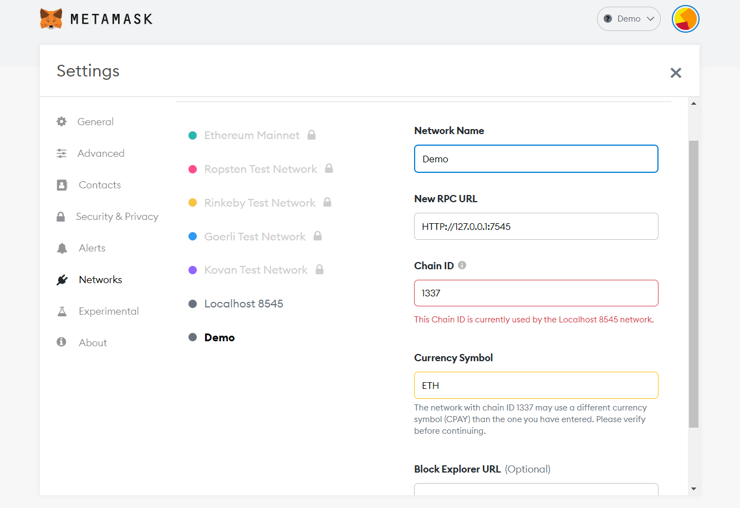

**Fig. 8 List of all networks offered by metamask in integration with blockchain**

* 1. **Application and it’s integration with metamask**

We created a react application using java script as a programming language the app contains 4 main files inside the src folder as listed below in Fig. 9 the files are as follow:

* App.js which combines all the folders below it and serves as an entry point for the application.
* ErrorMessage.js which contains the code for throwing any kind of error if occurred in between the working of the application it is important to have such a code in order for the application to work successfully and efficiently.
* TxList.js it contains the code for carrying out the transaction in integration with metamask.
* index.js this piece of code is responsible for validating and verifying the ETH recipient address and ETH value in integration to metamask.
* package.json this file contains the various packages needed for this application to operate and run properly it serves as a tool for this.

On the right-hand side of the Fig. 9 we can see the browsers interface it basically combines all the module inside the program and shows the output here.

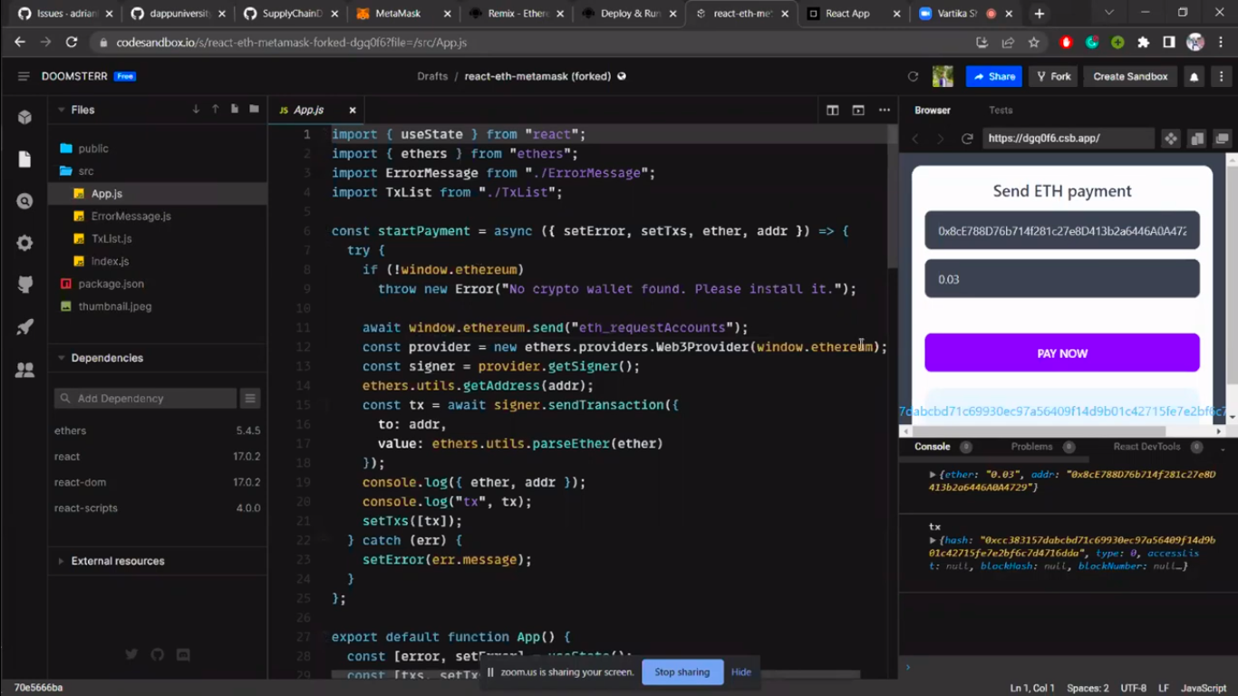

**Fig. 9 Application structure and code-base along with the browser interface**

The below Fig. 10 shows the browser after compilation of the code it has the following input options listed below:

* Recipient address – It is a unique address associated with the metamask account that can be obtained through metamask inside the profile section, by which the transaction for that particular account will be carried forward.
* Amount in ETH – It refers to the amount of the private Ethereum blockchain networks cryptocurrency value which is referred to as ‘ether’ or ETH.
* Pay Now button – This button is responsible for triggering the metamask browser extension, as soon as the button is clicked a metamask browser pops-up that verifies and validates the authenticity of both the accounts from where the payment is to be made and to whom it is to be made.

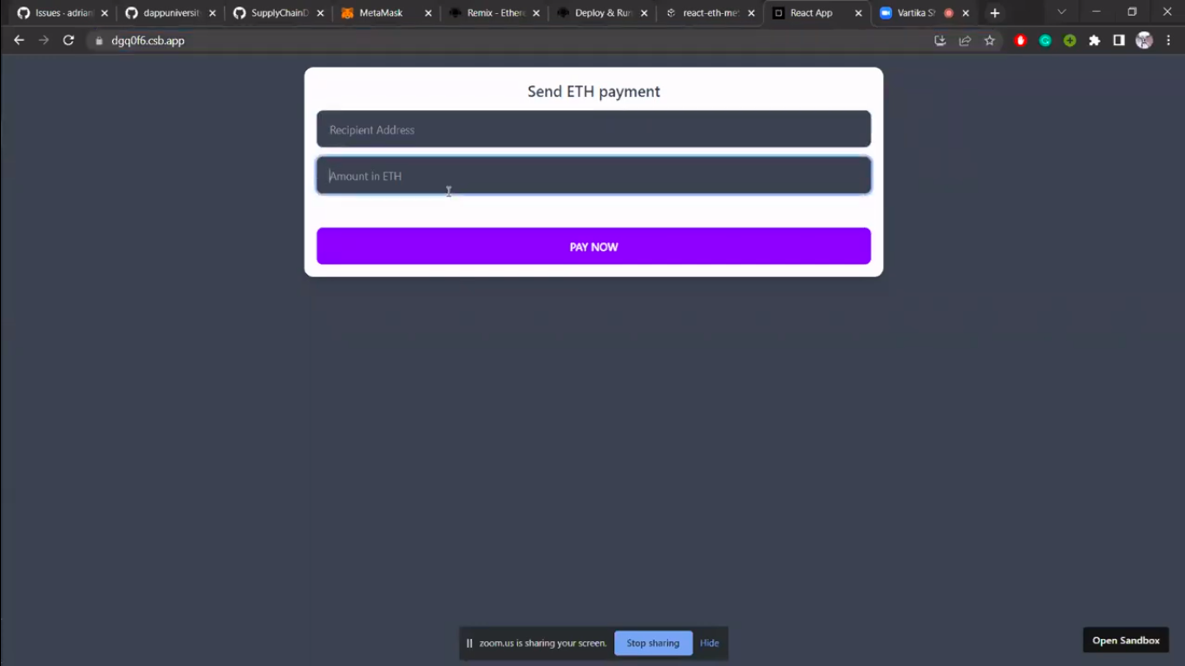

**Fig. 10 Browser interface**

In this case it can be seen that Account 2 has a balance amount of 99.93 ETH and Account 1 with the balance amount of 0.03 ETH which can be seen in Fig. 11, here we are making the payment from “Account 2” to “Account 1” which are listed in the Fig. 12.

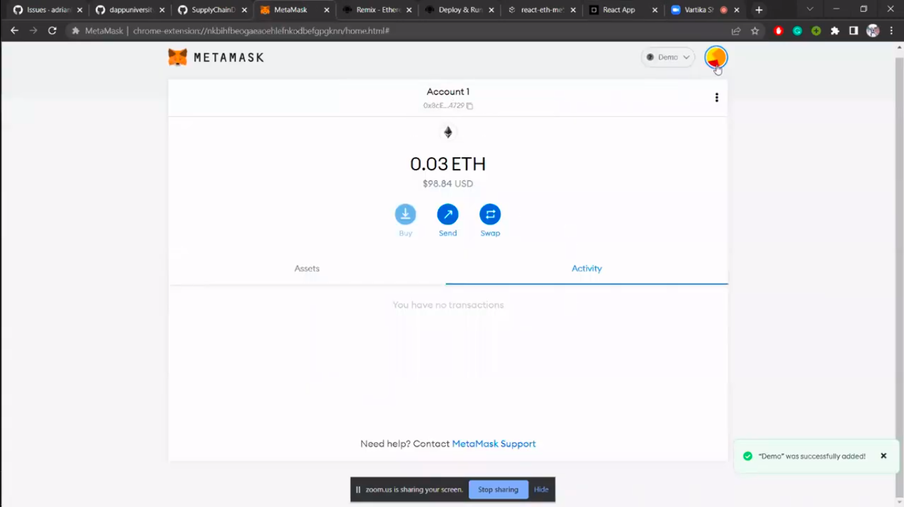

**Fig. 11 Details of the Account 1 associated with metamask**

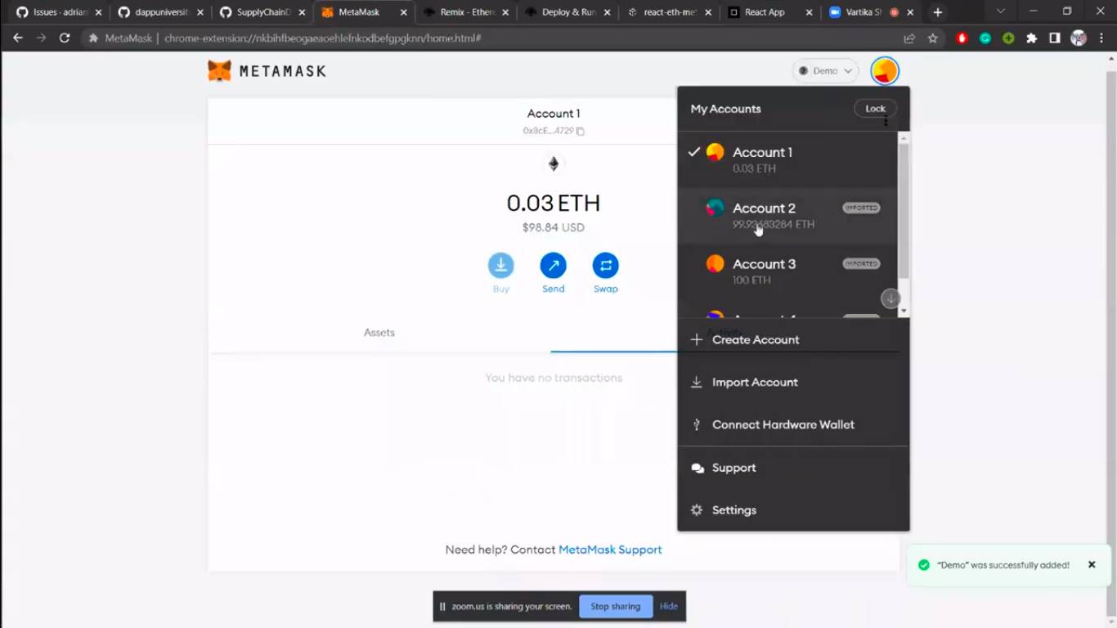

**Fig. 12 Account details associated with metamask**

Here in Fig. 13, we can see that the accounts unique address associated with “Account 1” has been copied and pasted in the recipient address input box. Also, in the amount section we are passing the value of 1 ETH for carrying out the payment

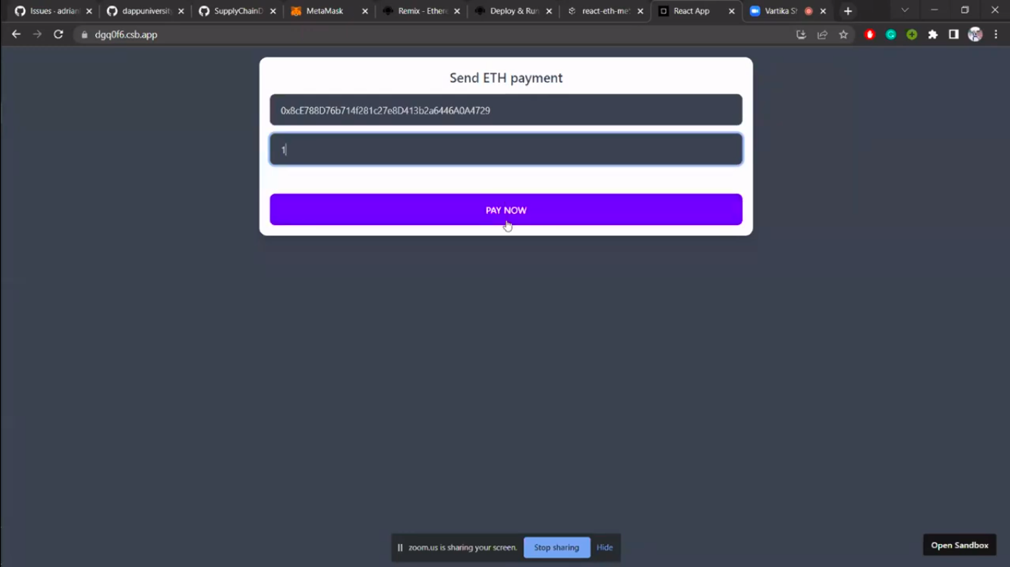

**Fig.13 Application browser interface with valid entries.**

In Fig. 14 we can see that ass soon as the “PAY NOW” button is clicked metamask browser extension pops-up which says “connect with metamask” which is verifying and validating the account from which payment is to be made i.e., “Account 2”. After that we have option below as “Next” and “Cancel”.

* Next will allow the connection.
* Cancel will cancel the payment request.

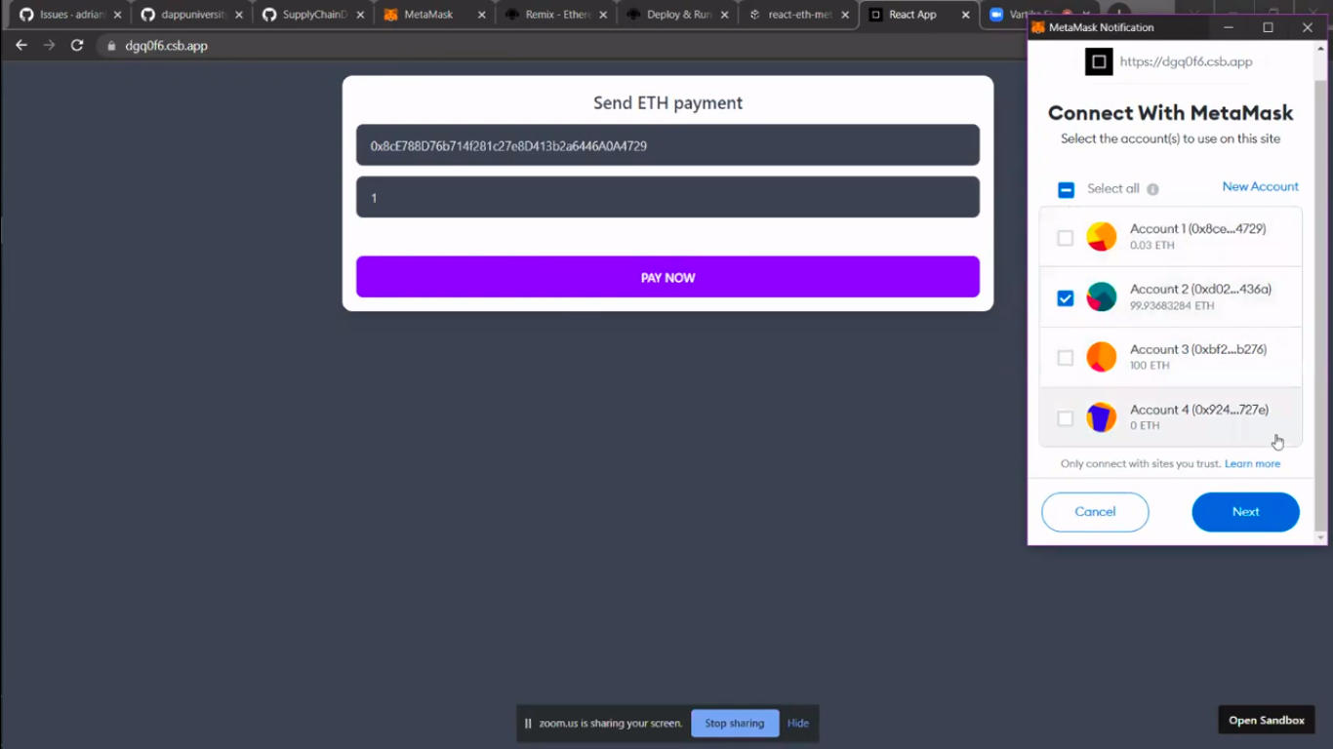

**Fig. 14 Metamask pop-up window**

Here in Fig. 15, we can see the connection being established between metamask and the application interface for validating and carrying forward the payment request in integration with metamask.

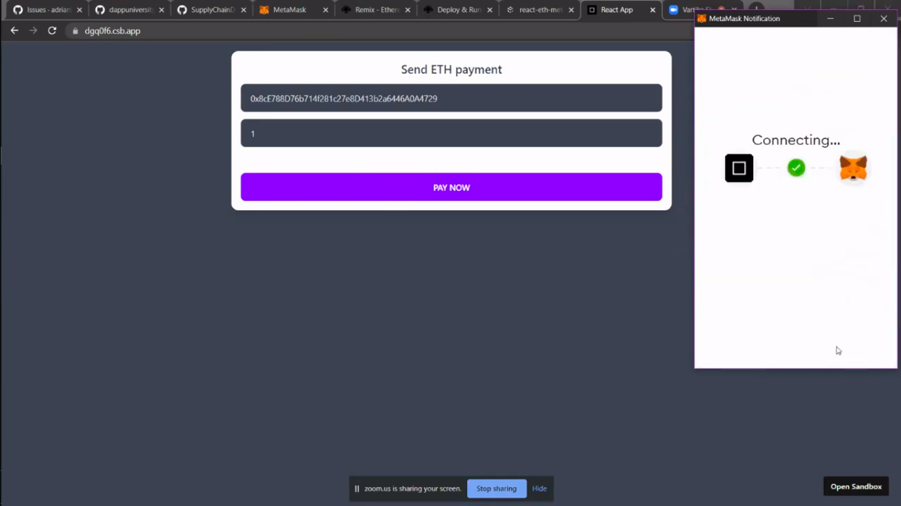

**Fig. 15 Establishing of connection between application and metamask**

In Fig. 16, we can see that the metamask extension is asking for the confirmation for the 1 ETH to “Account 1” also it has calculated the estimated gas fee which is 0.00042 ETH, and then summed up the total amount to 1.00042 ETH, gas fee here is the transaction cost or amount transfer cost it is applicable on all kinds of the valid transaction from one account to another account. We also have the option to reject the transfer request at this point if we wish not to go with it due to any reason.

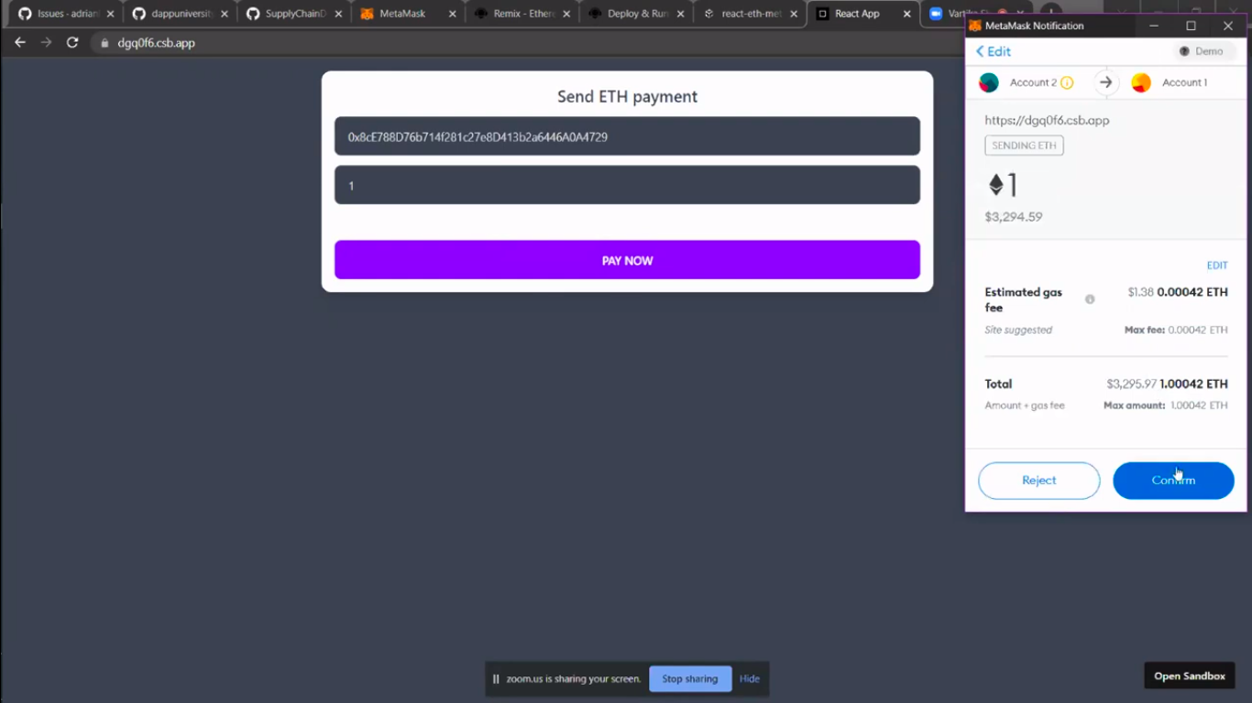

**Fig. 16 Transfer confirmation page for 1-ETH**

As soon as you click on to confirm you can see in Fig. 17, that the metamask extension closes and the transaction takes some instant for the ETH amount to get deducted from the user’s end.

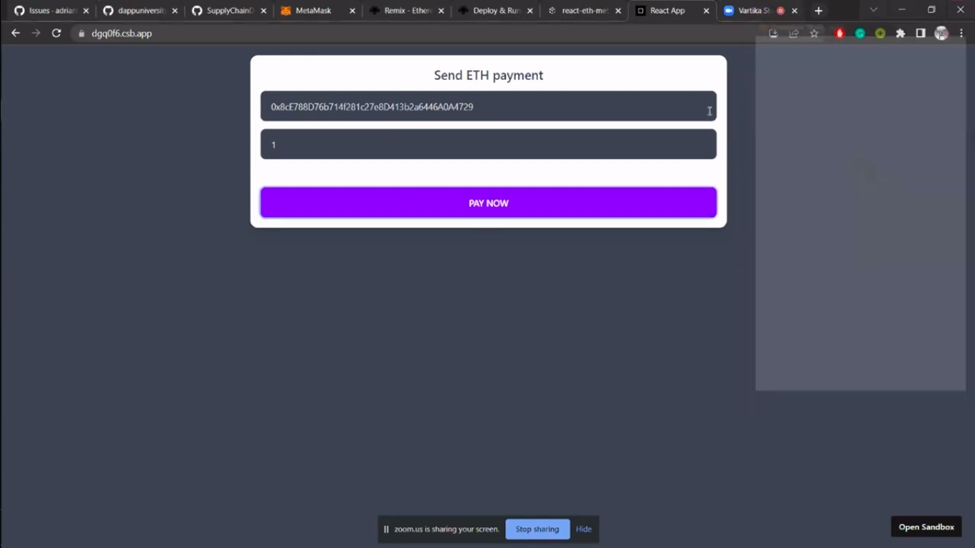

**Fig. 17 Payment processing page**

Once the metamask extension is closed we can manually go to the metamask web application and check the account status in our case “Account 2”. Here in the fig under the activity section of “Account 2,” we can see that the payment requests me made using our application is on top of the queue and the status can be seen as pending to account address, along with it we have other details as well such as amount to be deducted in ETH and its conversion in USD.

Below the queue section, we can also find the history section that has the record of all the previous deductions and transactions done on the account.

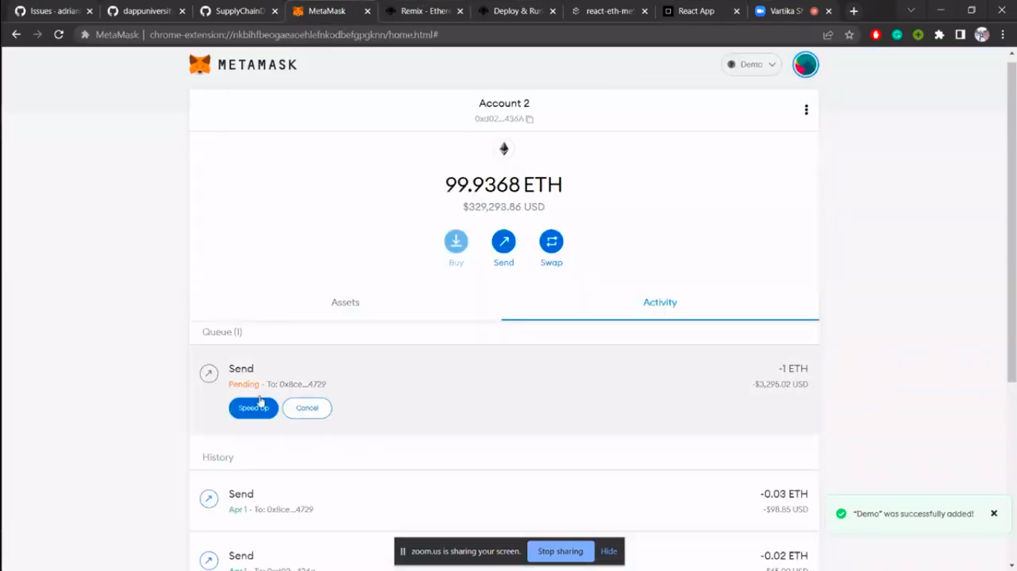

**Fig. 18 Metamask account transaction status 1**

Here in this Fig. 19, we can see that the status which was pending earlier in Fig. 18, is not marked as sent along with other details such as the date address of the receiver, and the amount that was deducted in ETH and its conversion in USD.

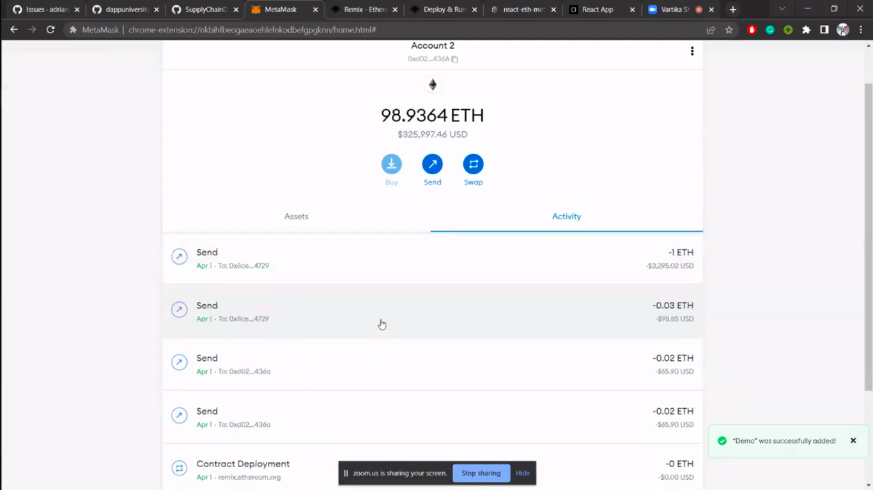

**Fig. 19 Metamask account transaction status 2**

If we navigate back to the account section and go to “Account 1” in Fig. 20, we can see the balance amount of the account it can be clearly seen that it received the amount that was sent using “Account 2”, the balance amount can be seen in both ETH as well as USD. Also in the top right corner, we can see which current network the account lies in.

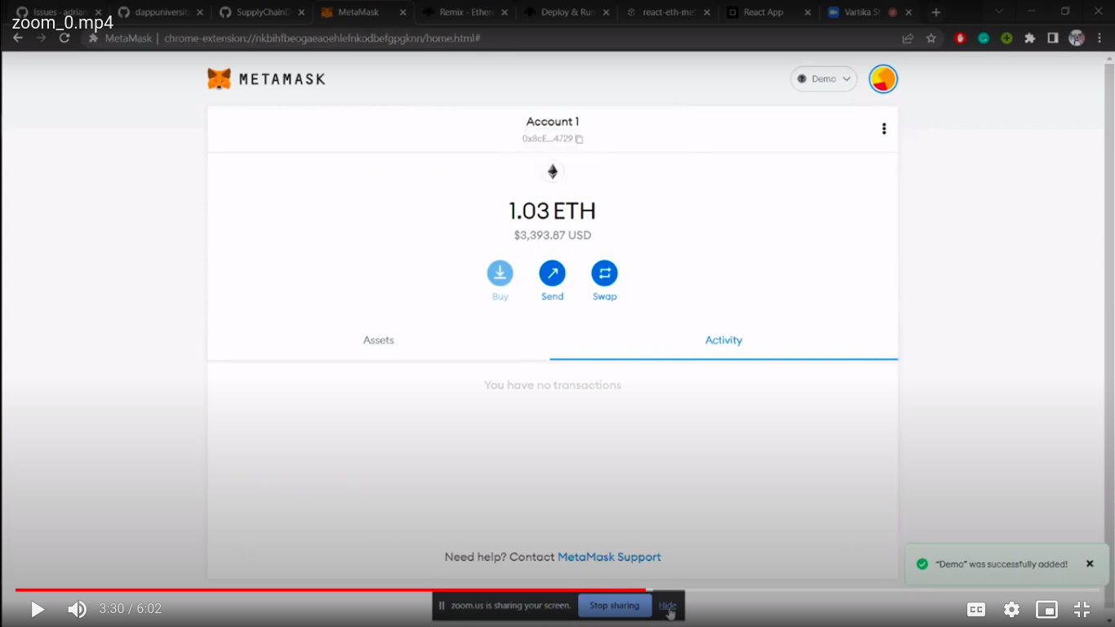

**Fig. 20 Metamask account transaction status 3**

1. **References**

[1] Shakhbulatov, D., Medina, J., Dong, Z., & Rojas-Cessa, R. (2020). How Blockchain Enhances Supply Chain Management: A Survey. IEEE Open Journal of the Computer Society, 1, 230–249. https://doi.org/10.1109/ojcs.2020.3025313

[2] Juma, H., Shaalan, K., & Kamel, I. (2019). A Survey on Using Blockchain in Trade Supply Chain Solutions. IEEE Access, 7, 184115–184132. https://doi.org/10.1109/access.2019.2960542

[3] Omar, I. A., Jayaraman, R., Salah, K., Debe, M., & Omar, M. (2020). Enhancing Vendor Managed Inventory Supply Chain Operations Using Blockchain Smart Contracts. IEEE Access, 8, 182704–182719. https://doi.org/10.1109/access.2020.3028031

[4] Chang, S. E., & Chen, Y. (2020). When Blockchain Meets Supply Chain: A Systematic Literature Review on Current Development and Potential Applications. IEEE Access, 8, 62478–62494. https://doi.org/10.1109/access.2020.2983601

[5] Yang, X., Li, M., Yu, H., Wang, M., Xu, D., & Sun, C. (2021). A Trusted Blockchain-Based Traceability System for Fruit and Vegetable Agricultural Products. IEEE Access, 9, 36282–36293. https://doi.org/10.1109/access.2021.3062845

[6] Al-Jaroodi, J., & Mohamed, N. (2019). Blockchain in Industries: A Survey. IEEE Access, 7, 36500–36515. https://doi.org/10.1109/access.2019.2903554

[7] Valle, F. D., & Oliver, M. (2020). Blockchain Enablers for Supply Chains: How to Boost Implementation in Industry. IEEE Access, 8, 209699–209716. https://doi.org/10.1109/access.2020.3038463

[8] Wang, S., Li, D., Zhang, Y., & Chen, J. (2019). Smart Contract-Based Product Traceability System in the Supply Chain Scenario. IEEE Access, 7, 115122–115133. https://doi.org/10.1109/access.2019.2935873

[9] Hafid, A., Hafid, A. S., & Samih, M. (2019). New Mathematical Model to Analyze Security of Sharding-Based Blockchain Protocols. IEEE Access, 7, 185447–185457. https://doi.org/10.1109/access.2019.2961065

[10] Belotti, M., Bozic, N., Pujolle, G., & Secci, S. (2019). A Vademecum on Blockchain Technologies: When, Which, and How. IEEE Communications Surveys & Tutorials, 21(4), 3796–3838. https://doi.org/10.1109/comst.2019.2928178

[11] Tsoulias, K., Palaiokrassas, G., Fragkos, G., Litke, A., & Varvarigou, T. A. (2020). A Graph Model Based Blockchain Implementation for Increasing Performance and Security in Decentralized Ledger Systems. IEEE Access, 8, 130952–130965. https://doi.org/10.1109/access.2020.3006383

[12] Asyrofi, R., & Zulfa, N. (2020). CLOUDITY: Cloud Supply Chain Framework Design based on JUGO and Blockchain. 2020 6th Information Technology International Seminar (ITIS). https://doi.org/10.1109/itis50118.2020.9321013

[13] Rouhani, S., & Deters, R. (2019). Security, Performance, and Applications of Smart Contracts: A Systematic Survey. IEEE Access, 7, 50759–50779. https://doi.org/10.1109/access.2019.2911031

[14] Hader, M., Elmhamedi, A., & Abouabdellah, A. (2020). Blockchain technology in supply chain management and loyalty programs: toward blockchain implementation in the retail market. 2020 IEEE 13th International Colloquium of Logistics and Supply Chain Management (LOGISTIQUE). https://doi.org/10.1109/logistiqua49782.2020.9353879

[15] Reyes, P. M., Visich, J. K., & Jaska, P. (2020). Managing the Dynamics of New Technologies in the Global Supply Chain. IEEE Engineering Management Review, 48(1), 156–162. https://doi.org/10.1109/emr.2020.2968889

[16] Hassija, V., Chamola, V., Gupta, V., Jain, S., & Guizani, N. (2021). A Survey on Supply Chain Security: Application Areas, Security Threats, and Solution Architectures. IEEE Internet of Things Journal, 8(8), 6222–6246. https://doi.org/10.1109/jiot.2020.3025775

[17] Fu, Y., &amp; Zhu, J. (2019). Big Production Enterprise Supply Chain Endogenous Risk Management Based on Blockchain. IEEE Access, 7, 15310–15319. https://doi.org/10.1109/access.2019.2895327

[18] Musigmann, B., von der Gracht, H., & Hartmann, E. (2020). Blockchain Technology in Logistics and Supply Chain Management—A Bibliometric Literature Review From 2016 to January 2020. IEEE Transactions on Engineering Management, 67(4), 988–1007. https://doi.org/10.1109/tem.2020.2980733

[19] Wu, Y., Yan, Z., Thulasiram, R. K., & Atiquzzaman, M. (2021). Guest Editorial Introduction to the Special Section on Blockchain in Future Networks and Vertical Industries. IEEE Transactions on Network Science and Engineering, 8(2), 1117–1119. https://doi.org/10.1109/tnse.2021.3073636

[20] Tran, Q. N., Turnbull, B. P., Wu, H.-T., de Silva, A. J. S., Kormusheva, K., & Hu, J. (2021). A Survey on Privacy-Preserving Blockchain Systems (PPBS) and a Novel PPBS-Based Framework for Smart Agriculture. IEEE Open Journal of the Computer Society, 2, 72–84. https://doi.org/10.1109/ojcs.2021.3053032

[21] G.S., R., & Dakshayini, M. (2020). Block-chain Implementation of Letter of Credit based Trading system in Supply Chain Domain. 2020 International Conference on Mainstreaming Block Chain Implementation (ICOMBI). https://doi.org/10.23919/icombi48604.2020.9203485

[22] Jayaprasanna, M. C., Soundharya, V. A., Suhana, M., & Sujatha, S. (2021). A Block Chain based Management System for Detecting Counterfeit Product in Supply Chain. 2021 Third International Conference on Intelligent Communication Technologies and Virtual Mobile Networks (ICICV). https://doi.org/10.1109/icicv50876.2021.9388568

[23] Shivendra, Chiranjeevi, K., Tripathi, M. K., & Maktedar, D. D. (2021). Block chain Technology in Agriculture Product Supply Chain. 2021 International Conference on Artificial Intelligence and Smart Systems (ICAIS). https://doi.org/10.1109/icais50930.2021.9395886

[24] Lei, S., Haiying, W., Haiyue, L., & Weiyu, T. (2020). Research of Innovative Business Classification in Bulk Commodity Digital Supply Chain Finance. 2020 International Conference on Computer Engineering and Application (ICCEA). <https://doi.org/10.1109/iccea50009.2020.00044>

[25] Ekawati, R., Arkeman, Y., Suprihatin, S., & Sunarti, T. C. (2020). Design of Intelligent Decision Support System for Sugar Cane Supply Chains Based on Blockchain Technology. 2020 2nd International Conference on Industrial Electrical and Electronics (ICIEE). https://doi.org/10.1109/iciee49813.2020.9276755

[26] Ahamed, N. N., Karthikeyan, P., Anandaraj, S. P., & Vignesh, R. (2020). Sea Food Supply Chain Management Using Blockchain. 2020 6th International Conference on Advanced Computing and Communication Systems (ICACCS). <https://doi.org/10.1109/icaccs48705.2020.9074473>

[27] Kaid, D., & Eljazzar, M. M. (2018). Applying Blockchain to Automate Installments Payment between Supply Chain Parties. 2018 14th International Computer Engineering Conference (ICENCO). https://doi.org/10.1109/icenco.2018.8636131

[28] Lopez-Pimentel, J. C., Rojas, O., & Monroy, R. (2020). Blockchain and off-chain: A Solution for Audit Issues in Supply Chain Systems. 2020 IEEE International Conference on Blockchain (Blockchain). https://doi.org/10.1109/blockchain50366.2020.00023

[29] Bhagavan, S., Rao, P., & Ngo, T. (2021). C3HSB: A Transparent Supply Chain for Multi-cloud and Hybrid Cloud Assets Powered by Blockchain. 2021 IEEE 37th International Conference on Data Engineering Workshops (ICDEW). https://doi.org/10.1109/icdew53142.2021.00025

[30] Shakhbulatov, D., Arora, A., Dong, Z., & Rojas-Cessa, R. (2019). Blockchain Implementation for Analysis of Carbon Footprint across Food Supply Chain. 2019 IEEE International Conference on Blockchain (Blockchain). <https://doi.org/10.1109/blockchain.2019.00079>